CHEAD Regional Seminar: The Role of Contextual Studies in Art School Education in Scotland
16th April 2015
Forum for Critical Inquiry, The Glasgow School of Art
Principle Seminar Room 1, Reid Building, 12:00-5:00pm
Organised by: Dr Sarah Smith
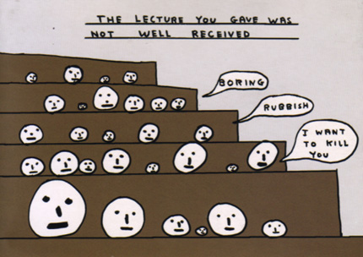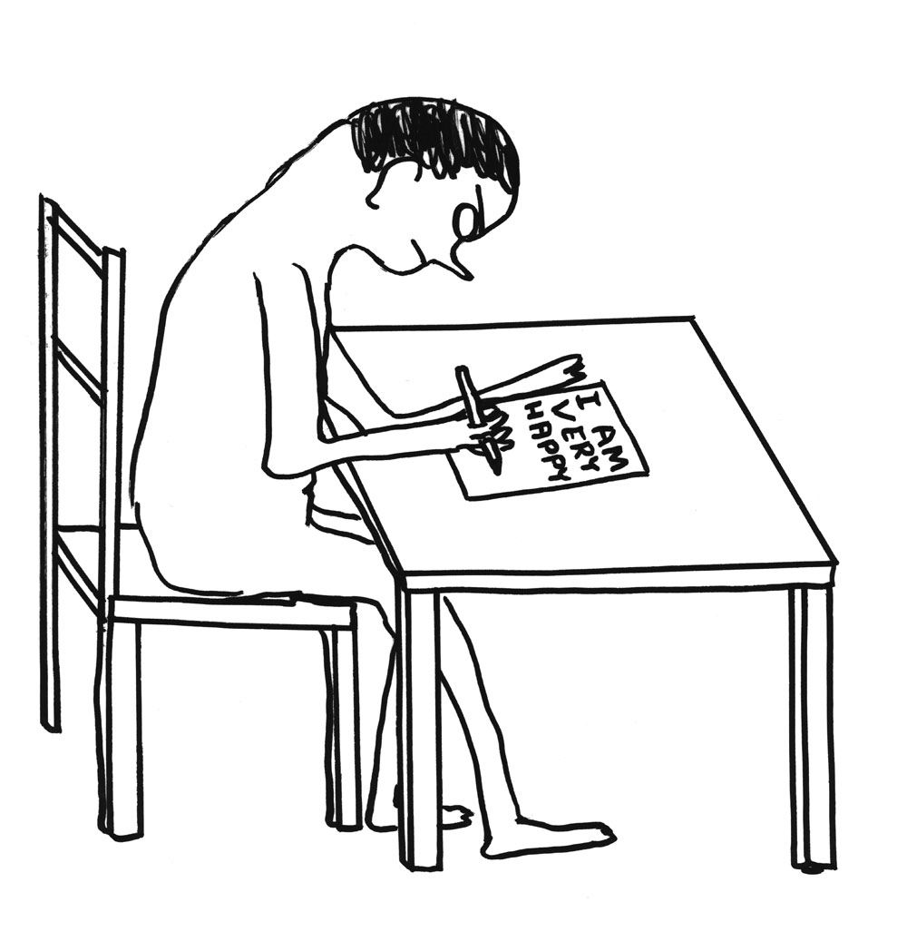
Images by David Shrigley (used in Dr Annebella Pollen’s keynote presentation)

Report for CHEAD

1. Context

This seminar was prompted by an institution-wide drive to reconsider the model of Critical and Contextual Studies (CCS) employed by The Forum for Critical Inquiry (FoCI) at The Glasgow School of Art in light of changes that had been made across the sector over the past decade. The event aimed to facilitate and stimulate scholarly debate on Art and Design Higher Education and to establish a regional network of Scottish CCS staff. Its particular focus on the role of CCS in Art and Design Higher Education taps into a theme of current national interest as exemplified by recent and forthcoming CHEAD and AAH projects and, by focusing on the regional context, we hoped to identify issues and opportunities that may be unique to the Scottish HE sector.

Recent changes to Art and Design Higher Education, precipitated by diverse drivers such as funding cuts and the emergence of the reflective practitioner, has brought the debate about the role of CCS back into sharp focus. A central question for any such investigation is: if the role of CCS is no longer ‘to elevate’ and ‘lend academic credibility’ to studio practice, as was the case when the history and theory of art and design were first introduced to art-school Higher Education following the Coldstream Reports (1960, 1970), then what do we see as its role both now and in the future?

Across the UK there exists a variety of curricular and organisational CCS models, which are reflected in the different approaches taken by the four Scottish art schools: The Glasgow School of Art (GSA), Edinburgh College of Art (ECA), Duncan of Jordanstone College of Art and Design (DJCAD) and Gray’s School of Art, University of Aberdeen. This event brought together CCS scholars from all four Scottish art schools to share best practice across our various models and to debate the central question: what is, and should be, the role of Critical and Contextual Studies in Art and Design Higher Education today?

This seminar was part of a wider research project, led by FoCI’s Joint Heads of Dept (Dr Sarah Smith and Nicholas Oddy), which was innovative in its approach to research, consultation and dissemination in that its reach extended beyond all previous reviews undertaken by our department. In particular, by engaging staff from other Scottish HEIs in scholarly debate, we provided an inclusive platform to share best practice and debunk some persistent myths about the nature of CCS teaching at art schools and by including graduates (and not only current students) in our consultation and research, we asked key questions about how CCS curriculum (and the skills and knowledge acquired therein) has influenced graduate destinations, both in terms of PGT, PGR and employment. Our research also included visits to other UK HEIs such as University of Wolverhampton, University of Brighton, Kingston University, the Royal College of Art (RCA) and Central Saint Martins (CSM, UAL) to gain insight into a range of other CCS models.

2. The Seminar

The seminar, which was advertised using GSA social media and FoCI staff’s own professional networks, proved hugely popular, testifying to the currency of the theme and to the desire to debate its central issues. Because of high demand, we increased our original cap of thirty places to thirty-six, which included delegates from around Scotland and a small number from the rest of the UK (Coventry University, de Montfort University, University of Brighton and Bath Spa University). While the majority of delegates were contextual studies staff, we were pleased to have GSA’s Heads of Research and Learning & Teaching in attendance; notably – and regrettably – there was no representation from studio-based staff (perhaps due to its timing). We also welcomed a lecturer from the City of Glasgow College, a local FE Institution, which we thought was particularly important in light of the current enhancement theme of ‘Student Transitions.’ The event began with registration and lunch, providing everyone with an opportunity to network before the presentations.

The seminar opened with a keynote from Dr Annebella Pollen from University of Brighton, who presented an overview of a piece of pedagogic research she had recently published with Design and Culture. Her paper, which was titled ‘Theory and Practice: Objective and Subjective?,’ critiqued the perception of the ‘academic element’ of studio-based programmes as lacking in subjectivity and personal investment, instead arguing that Design History is an embodied, reflective and affective discipline.

Two lecturers from each of the four Scottish Art Schools then gave short presentations on Critical and Contextual Studies within each of their institutions, offering either overviews of the curricular and operational model employed at their institution and their role within it or focusing on examples of innovative practice that, for instance, combined studio and CCS methodologies and techniques (visual presentation, collage, assemblage, collecting, curating, writing) to design critical studies courses. Those who presented were:

- Dr Anna Notaro, Semior Lecturer in Contemporary Media Theory, DJCAD
- Dr Euan McArthur, Senior Lecturer, DJCAD
- Dr Angela McClanahan, Director of Visual Culture, ECA
- Dr Jonny Murray, Director of Design Context, ECA
- Andrea Peach, Lecturer in Contextual and Critical Studies, Gray’s School of Art
- Iain Irving, Course Leader for Masters in Contextualised Practice, Gray’s School of Art
- Dr Sarah Smith, Joint Head of Dept, FoCI, GSA
- Nicholas Oddy, Joint Head of Dept, FoCI, GSA

Numerous differences emerged in the various models and approaches employed by each of the four institutions and, it was clear that in each case the operational model impacted considerably on the L&T practices e.g. ECA and GSA are in a position to offer team-taught courses and a diverse range of electives because they have separate CCS departments that work across programmes, whereas in DJCAD staff tend to be attached to specific programmes and work in a more isolated way or, where possible, in pairs (certainly there is no sense of there being a strategic approach to CCS provision – and related research – at institutional level at DJCAD). Perhaps because CCS at Gray’s School of Art has been through several different operational and pedagogic iterations over the past ten years (from being a separate Dept, to being fully integrated, back to being a separate Dept), they seemed well placed to propose courses that endorsed innovative practices to engage students with CCS.

The closing keynote by Professor Neil Mulholland, Director of Postgraduate Studies at ECA, provocatively titled ‘Juche: Art School State of Mind,’ was based on his article for the New Art West Midlands 2014 exhibition catalogue, which presents a position that he is currently developing as part of a more sustained research project into art school pedagogy. His central thesis posits that, while there is exciting scope for developing radical pedagogies within art schools, the insular culture fostered therein since modernism stymies opportunities for curricular diversity. Having a broad-based contextual studies goes some way towards challenging the monoculturalism that art and design education can, at times, endorse; it does so both by fostering critical thinking and by facilitating the student’s development of a different skill set.

The keynotes from Bella and Neil provided the sort of framing that we had hoped they would, by asking provocative questions about what art school education is and should be in the twenty-first century, by considering how to challenge ossification where it exists and how to reconceptualise the role of contextual studies as part of a diverse curriculum. The short presentations from each of the four Scottish art schools gave us a chance to see what and how we teach and to share good practice. Perhaps the most valuable aspect of the seminar was the opportunity it afforded us to meet together and talk about issues that we share as contextual studies staff working within art schools.

3. Future Developments and Reflections

Since the event, I have followed up with an email to all Scottish art school staff to discuss the next steps for developing a Scottish Network for Contextual Studies. Discussions at and after the event suggest that there is a strong desire to establish a biannual themed seminar hosted by a different institution each time and drawing on existing research as well as becoming a catalyst for new research. While a seminar might be our key activity, other outcomes of the network (which could provide the focus for the seminar) might be:

- Proposing panels on art school education or on any shared research interests for major national and international conferences such as AAH, MeCSSA, Screen, CAA, IASDR Congress, ICDHS and SCMS
- Co-authoring papers or books in shared research areas
- Sharing our existing networks in supporting each other’s teaching and research
- Informal teaching exchanges on a quid pro quo basis
- Developing cross-institutional courses and programmes in critical and contextual studies
- Developing cross-institutional funding bids.

Some activity which developed from the seminar’s networking opportunity is already underway: staff at GSA and Gray’s are in the process of developing a research project on ‘Seventies Design’ and we are considering applying for Network Funding to develop one particular research thread, which may be pedagogic research.

The main objective of the project that this seminar formed part of is to reconsider the role and position of CCS at GSA and that project is ongoing. The key outcome will be the proposition of a new model, which recognises and enhances the strengths of the education currently provided whilst facilitating the growth and diversification of CCS teaching (and research) at GSA and collaborative opportunities with other parts of GSA and with external bodies.

This event was originally scheduled to take place in June 2014, but was postponed due to the fire at GSA’s Mackintosh building. CCS at GSA has undergone major restructuring in the interim, following the decision not to replace the Deputy Director when the previous post-holder left to take up a new role elsewhere. From roughly March to November in 2014 GSA had explored the possibility of growing CCS and developing new programmes within the broad area of Visual Studies, a route that would have consolidated and built upon the cross-School (cross-programme) teaching that we provide; a model that has been successful in many other Art and Design HEIs. However, those plans have now been shelved and the FoCI department has recently been split between the School of Design and the School of Fine Art. The educational rationale for this operational change and its effect on students has yet to be fully considered. This seminar has been extremely timely for us, therefore, in taking the lead on what that educational rationale might be, informed by examples of good practice of integrated models elsewhere.

This seminar was funded by CHEAD and the wider research project was funded by GSA’s Learning and Teaching Enhancement Fund. We would like to thank both for their support.

Annebella Pollen, ‘My Position in the Design World: Locating Subjectivity in the Design Curriculum,’ Design and Culture, Volume 7, Issue 1, pp.85-106
Neil Mulholland, ‘Juche: Art School State of Mind,’ http://newartwestmidlands.org/wp-content/uploads/New-Art-West-Midlands-catalogue-2014.pdf

